# AI Applications in Real Life

**Module 3**

**Table of Contents**

Learning Objectives 4

Exposure to AI Using Apps 4

Cloud Computing Services 4

Major API’s 5

Exposure to Digital Assistant and Other Applications 17

Personal vs. Digital Assistant 17

Cortana 17

Speech recognition 19

Spell Checker 20

Exposure to Cloud based AI, & Online Collaboration Tools 21

Online collaboration tool 21

Data insights from excel sheet using Power BI 22

AI Applications 23

Introduction to AI Applications on Azure 23

Cognitive Services - Face API 25

AI Developer Boot Camp 25

Drone Rescue 25

Cognitive Services 26

AI Natural Language Processing 26

Optical Character Recognition 26

Image Classification 27

Textbook Assessments 28

Practical Assignments 29

Assignments/Questions to Ponder Upon 30

Further Reading 32

Reference Links 33

**Glossary……………………………………………………………………………………………………………………3****4**

**Disclaimer:**

The Imagine Cup Junior guides and lesson materials are created by Microsoft and our partners and intended to be for guidance only to support with the Imagine Cup Junior Challenge. For the latest on Microsoft AI please visit <https://www.microsoft.com/en-us/ai>

Learning Objectives

This module is designed to get students to understand basic applications which use artificial intelligence to help humans streamline their work in various ways. These applications are used in day-to-day life and are operated by simple human language-based commands. The main aim of this module is to give students an overview of AI and understand how cloud computing works in real life applications. At the end of the module, students should be able to:

* Understand the basics of AI and other related concepts.
* Understand the working of a digital assistant and how it helps us in our life.
* Have exposure to AI cognitive services applications imitating decisions and actions of humans.
* Appreciate the need to incorporate AI in real-life scenarios using the Azure platform.
* Solve challenges at a professional level through cloud computing.

Exposure to AI Using Apps

An Application Programming Interface (API) is a set of commands, protocols and functions used in programming to create software capable of interacting with an external system. The APIs are one of the main elements of cloud services. It is important to know in brief about cloud computing before we study APIs as it ensures data-portability and interoperability.

# Cloud Computing Services

Cloud Computing is a system of using a robust network of remote servers hosted on the internet to store, manage, and analyze data. It runs on the internet rather than a local server or personal computer. A computer system connected to the cloud keeps its critical data on the cloud servers rather than distributing copies of data files to individual local client devices. Video-streaming cloud services for example stream data across the internet to a player application on the viewing device rather than sending customers a Digital Versatile Disc (DVD).

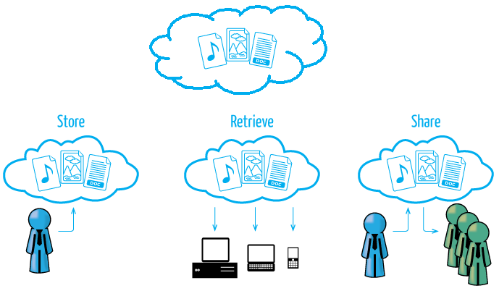

Fig 3.1: The working of cloud computing

# Major API’s

Below is a list of the major APIs that are simple to use and easy to practice.

Face API is a service designed to detect faces with attributes of facial recognition.

## Facial & Emotion Recognition

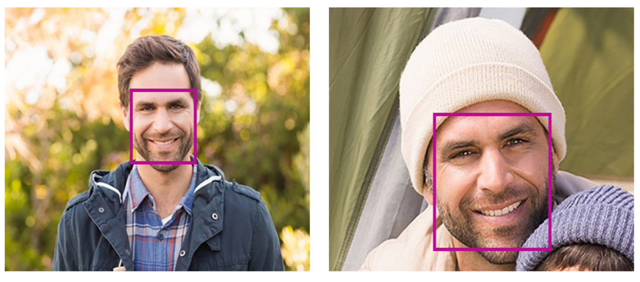

Fig 3.2: Face and emotion recognition using the API

The face recognition application is built to detect one or more human faces and return face rectangles in addition to various attributes of the face. These contain machine learning predictions of facial features. The API is designed to detect faces in the images and identify these features. The API can also be used to analyze videos in real-time by looking at individual frames.

There are more than 27 landmark points for any human face and a few attributes of features that are available in the API are as follows:

* Age
* Emotion
* Gender
* Pose
* Smile
* Facial hair

Based on these ‘landmarks’, the Application Programming Interface (API) can do the following:

## Face identification

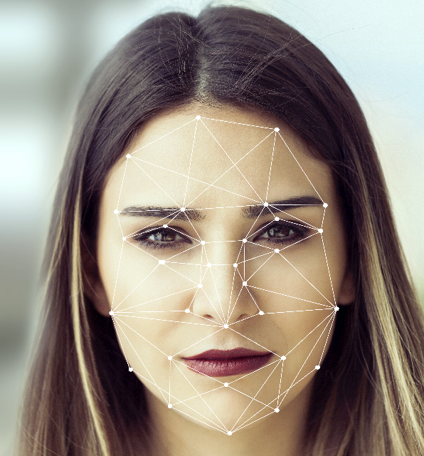

Fig 3.3: Face Identification using the API

The Face API allows searching, identifying and matching faces based on training faces saved in a repository of up to 1 million people. The API searches the face of the human and matches certain points on the face marked as identifiers. It recognizes the face before giving the output.

## Similar face search

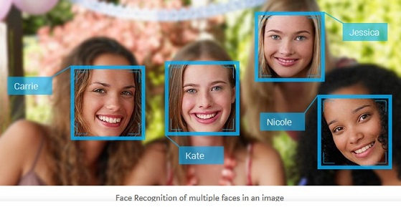

Fig 3.4: The App searching for familiar faces and tagging them

The API analyzes and finds faces that look similar. A query to that effect returns a collection of similar faces as seen in the example mentioned above.

## Face grouping

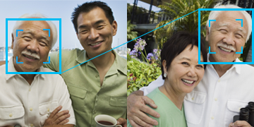

Fig 3.5: Grouping of similar looking faces in different images

The API organizes images of unidentified people based on the presence of a common face. You can observe a similar feature in some popular social media platforms which picks up random images and groups them based on the presence of the faces of people who are in your friends’ list. The API also automatically tags people to help the user.

## Emotion Recognition

The Face API also recognizes the emotions displayed by the human face. The API distinguishes between emotions such as anger, happiness, contempt, fear, disgust, sadness, and even surprise. The API is smart enough to understand human emotions and expressions across cultures. It also understands the way people universally communicate using particular facial expressions.

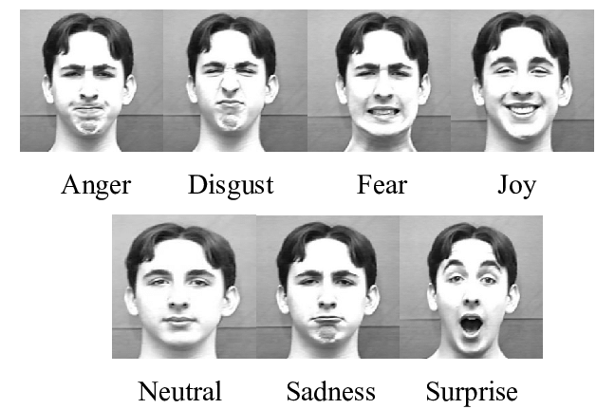

Fig 3.6: Basic six types of emotions

## Speech Authentication

The Speech Conversion API is an enormously powerful tool capable of listening to a live voice or a recording and converting it into text. This can be an immensely powerful verification tool where the unique voice of a person can be used to ascertain and validate the identity of the person. It is necessary to complete a process called ‘enrolment’ to train the API in the user’s voice.

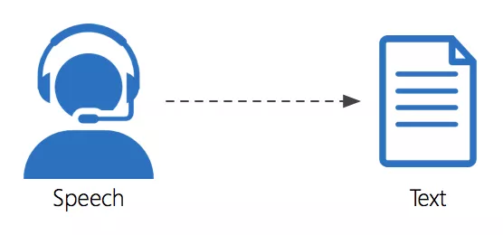

Fig 3.7: Process of Speech conversion into Text

This process is mandatory and requires the user to record three audio samples of his or her voice to register it with the software system.

## Conversation transcription

With the collaboration of different teams becoming a reality of modern work culture, conversation transcription can be very useful in meetings as it can create a transcript of the meeting, allowing participants to check their notes against the full transcript later on. Or using other software APIs translate this into another language for participants from another country. The API captures the speech of all participants in the real-time scenario and creates a transcript. This enables participants to engage in the meetings/discussions irrespective of the geographical locations. Here are a few more benefits:

It captures the voices of multiple participants in a given room.

It safeguards the data by following the mandatory security and compliance certifications as per the industry guidelines

It supports meetings and conferences wherein there is the use of microphones and video cameras pairing them with the speech devices

## Speech transcription

It converts spoken audio into text. It calls the API to recognize audio from a microphone, other real-time streaming audio source, or a recorded audio file. As the audio is directed to the server, a limited amount of speech-to-text recognition results are created once the request is made. Speech recognition technologies combine multiple APIs to produce text output. Users can customize the APIs to their needs and availability of data. This can:

* Provide customization to the language model of your speech recognition app by modifying it to meet the requirements of the industry, technology, geography, or market.
* Allow an authoritative, personalized recognition of the speech by building a customized model of speech recognition.

## Text Analytics

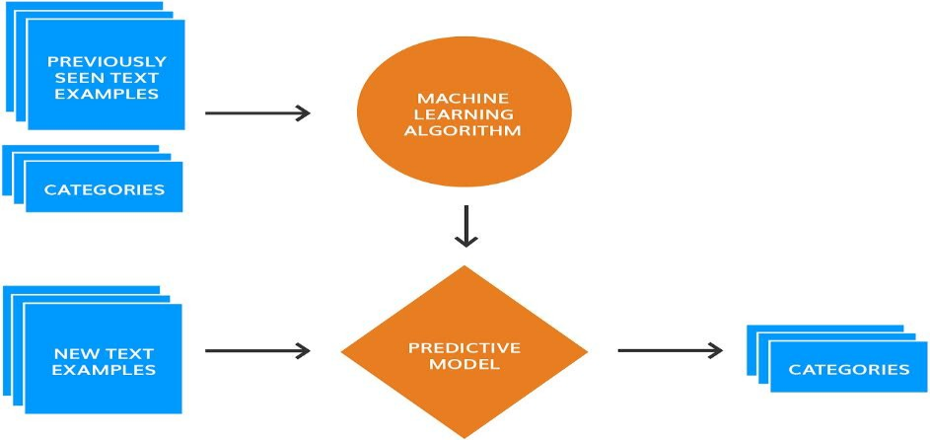

Fig 3.8: Process of Analysis of the Text

Text analytics is the process of converting unstructured text data into meaningful data for analysis, to measure feedback, for sentimental analysis, and other studies. Text analysis uses many linguistic, statistical, and machine learning techniques. A text analytics application can easily evaluate sentiment and other functions to understand what users want. This is accomplished by the following additional analysis:

## Sentiment analysis

The API returns a numeric score between 0 and 1, 0 indicating negative sentiment and 1 indicating positive sentiment. It is generated using classification techniques and supports many languages.

**Example –**

Positive sentiment – I am feeling **happy** after getting my new T-shirt.

Negative Sentiment – I am **sad** because I missed the movie.

## Key phrase extraction

The API returns a list of strings denoting the key phrases in the input text using Microsoft Office's sophisticated Natural Language Processing toolkit. English, German, Spanish and Japanese texts are all supported.

**Example –** “I have a smart phone. It has a memory of 8 GB, a fast processor, and I use it a lot”.

**Key phrase** – smartphone

## Language detection

The API reads the detected language and a numeric score between 0 and 1 is then assigned to it. A score close to 1, is an indicator that the language identified is correct. A score farther from 1 and closer to 0 means an incorrect identification of the language. The API supports a total of 120 languages.

Example – “Find a Casa Colorida in your preferred location”.

English language – Find/ a/ in/ your/ preferred/ location/

Spanish Language – casa/ colorida

Since most of the words detected are in English, the language detected is English.

## Named Entity Recognition

The API detects all named entities in a given text written by the user. This feature is used to rank the page on the web. Categories can be names of people, monetary values, locations, time expressions, percentages, and even organizations etc. It adds a wealth of semantic knowledge to the content and helps the machine instantly understand the subject and/or the context of any given text.

## Language Understanding

A machine learning-based service aims to build natural language understanding into apps, BOTs and IoT devices. It can quickly create enterprise-ready, custom models which continuously improve with each user experience.

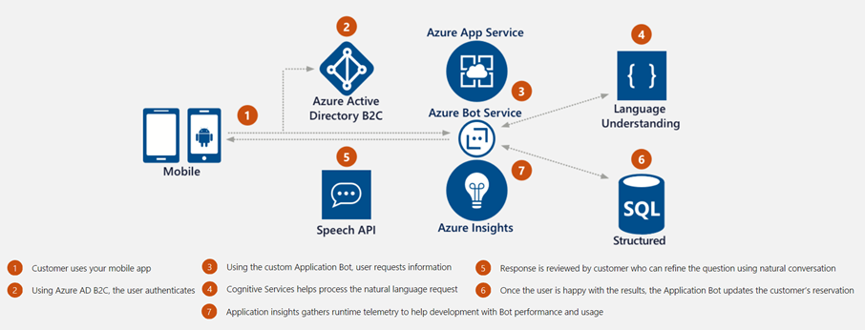

Fig 3.9: Azure App Cloud Service

Adjectives in the text are treated as sentiments whilst nouns and verbs are used to extract what the topic is, thus enabling a relatively simple understanding of the sentence by the machine. The language understanding API is:

* Designed to recognize the valuable information in the conversations and can interpret what the user wants.
* A solution that can accommodate customization of its in-built apps and dictionaries so that deployment of the solution is effective and fast.
* Used to continuously improve the quality of the natural language processing models, allowing the model to be constantly updated and improved.
* Ready to be deployed for commercial applications and scaled without affecting the quality and performance. It is built as per the compliances and can support 12 languages.

## Video Indexer

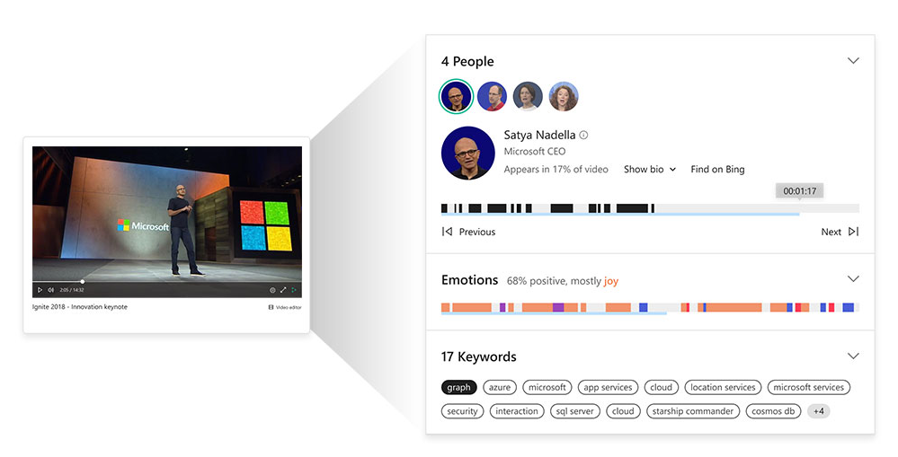

Fig 3.10: Video Indexing in Progress

A Video Indexer gives you access to video statistics such as how long people view your video ad for. It is recommended especially if you have linked your video to a particular webpage.

## Sketch2Code

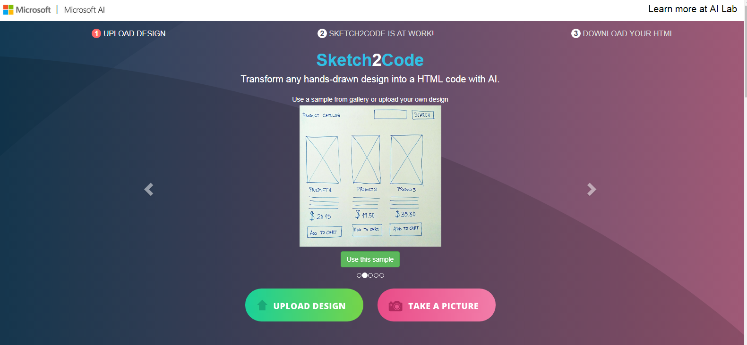

Fig 3.11: Sketch2code

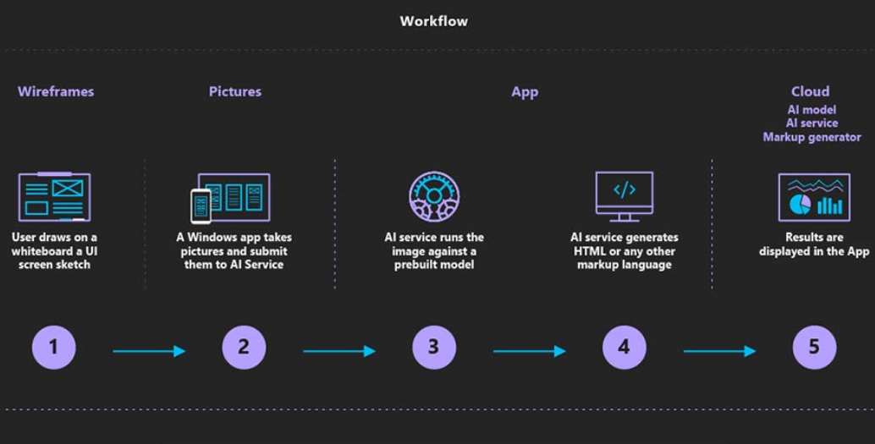

Fig 3.12: Working of Sketch2code

Let’s understand the process of transforming a handwritten image to HTML using Sketch2Code in more detail. We will use this application to develop a website just by converting a hand drawn sketch into HTML. Let’s consider a scenario, where a 10th grader is applying for admission into the next grade. The school has certain criteria for the selection of students for a particular stream. Now let’s sketch how those basic details will appear on the screen and process it.

First, the user uploads an image through the website.

* A custom vision model predicts what HTML elements are present in the image and their location on the page.
* A handwriting text recognition service reads the text inside the predicted elements.
* A layout algorithm uses the spatial information from all the bounding boxes of the predicted elements and generates a grid structure that accommodates all the elements.
* HTML Code is then generated and presented in full to the user.

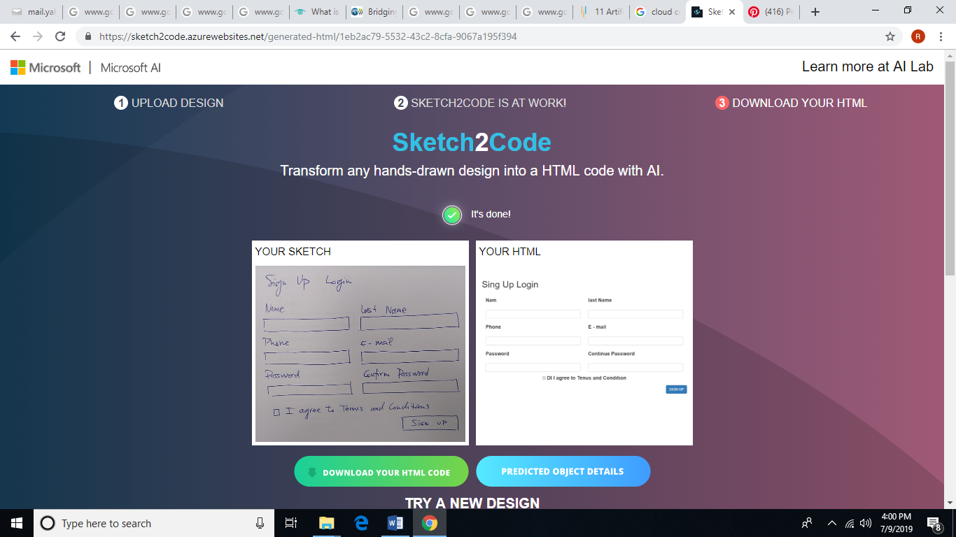

Fig 3.13: Working of Sketch2code

# 

Exposure to Digital Assistant and Other Applications

# Personal vs. Digital Assistant



A personal assistant is a person working exclusively for one particular person.

E.g., Peon, Secretary, Assistant

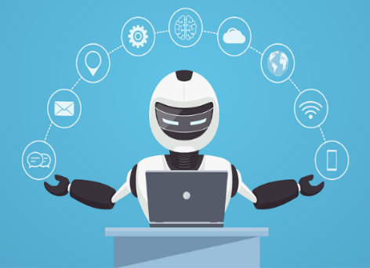

A digital assistant is a computer program designed to assist people.

E.g., Cortana, Alexa, Siri

Fig 3.14: Personal vs. Digital Assistant

## Cortana

(*Image and content : Courtesy – <https://support.microsoft.com/en-us/help/17214/cortana-what-is>)

Cortana is Microsoft’s digital assistant whose mission is to help its user get things done. Cortana has a few basic functions you can use without being signed in, but you can get far better functionality when signed into your Microsoft account. To sign in, within Cortana’s search window click the button that says, “Cortana can do so much more.” When prompted to click the sign-in button and follow the on-screen instructions.

If you’re the only user of your computer, or you simply want this function to be more accurate, click the blue text, which says ‘Hey Cortana.’ The search program will guide you through a series of tests to ensure your microphone is working correctly and will “learn” your voice so that you can instantly activate the Cortana window with the phrase from any screen.

If you want to make sure Cortana is obedient to you alone, tick the box that says, “Try to respond only to me.”

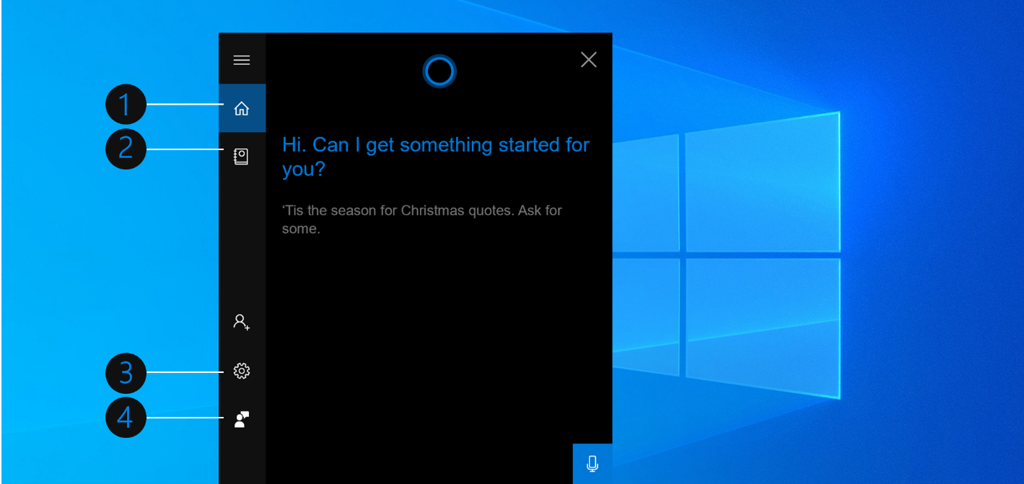

1. Home 2. Notebook 3. Settings 4. Feedback

Fig 3.15: Cortana

## What can Cortana Do?

* Send you reminders based on time, places, or people.
* Play music, podcasts, and radio stations.
* Find facts, files, places, and info.
* Perform calculations
* Find facts
* Check the weather
* Get directions
* Set alarms
* Launch programs

It (She) can also send emails and texts, manage your calendar, open any app on your system and perform many more functions.

## Set reminders

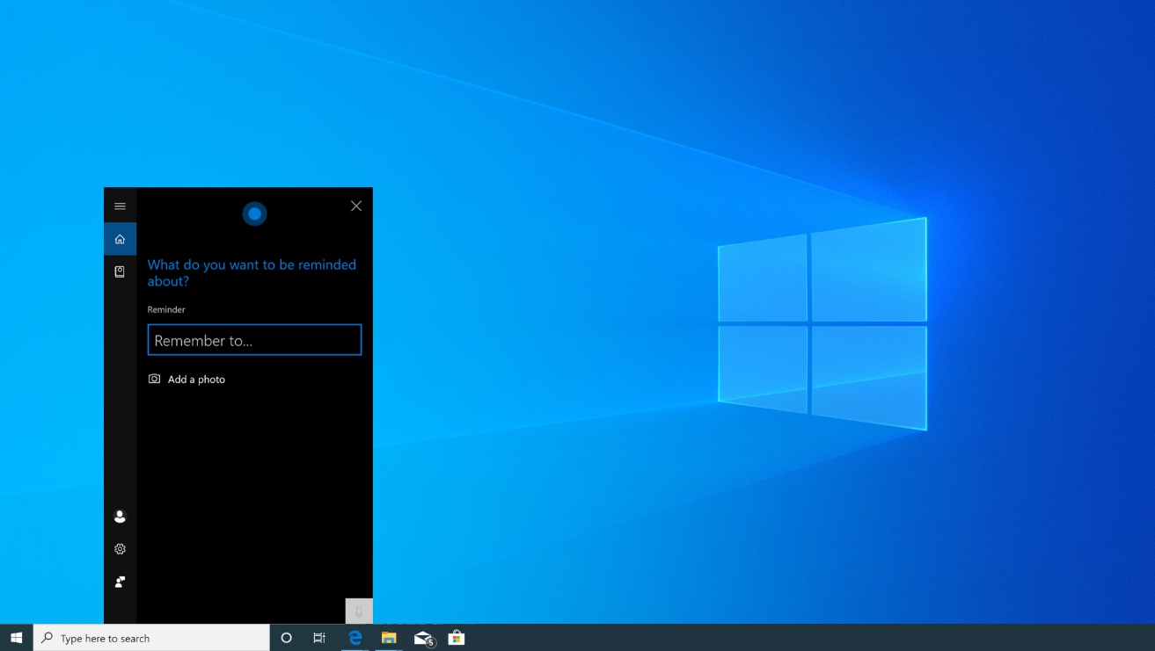

Fig 3:16: Set reminders

You can create a reminder and Cortana will remind you about it at a specific time, a specific location, or talking to a specific person. You can also say something like “Remind me to brush my teeth at 8 pm” to instantly create a reminder.

## Identify a song

Cortana can listen to a song playing near you and identify it. If the user asks, “What is this song?” Cortana uses your microphone to listen to the music and tries to match it to a specific song title. This works well with recorded music but not necessarily with live music.

Search the Web with a browser

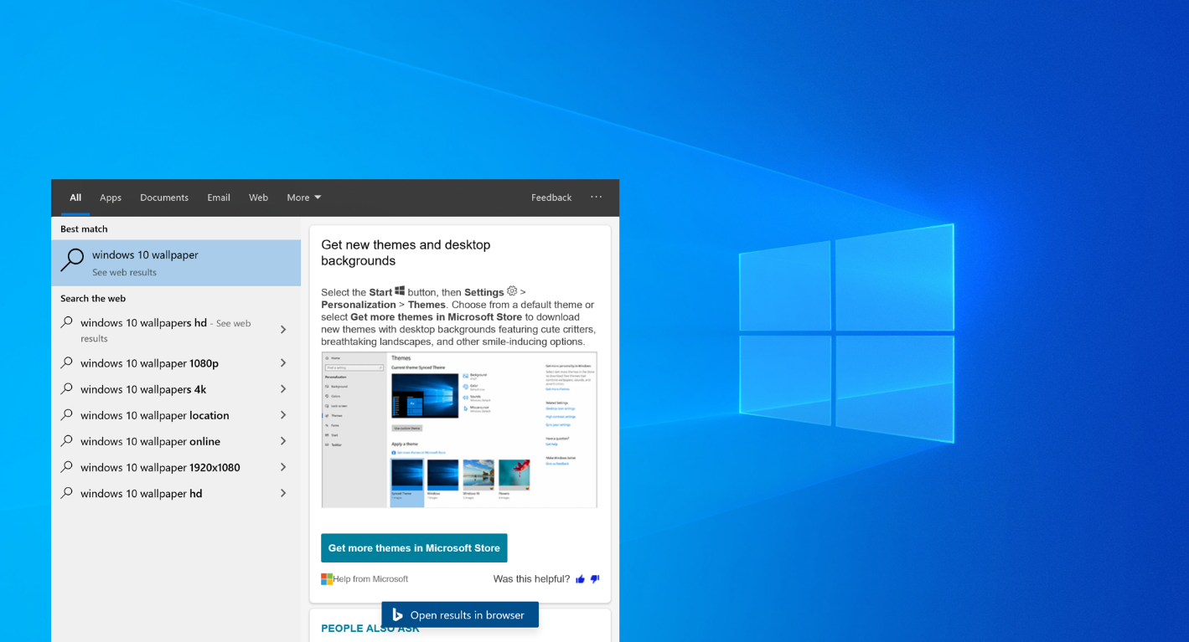

Fig 3.17: Searching on the web

You can make Cortana use a browser instead or another search engine such as Yippy Search.

## Perform Calculations and Conversions

Cortana can also perform quick calculations. You can ask Cortana for the answer to a calculation such as “what is 567341 multiplied by 765934” or a unit conversion such as “what are 76 Dollars in British Pounds”. This works for currencies as well as other types of units.

## Find Facts

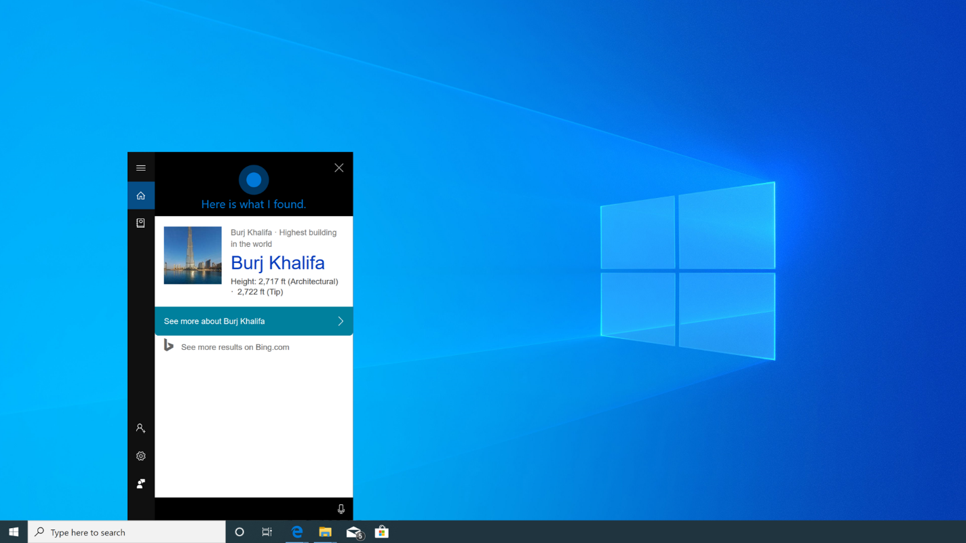

Fig 3.18: Finding facts

Cortana uses Bing as the default browser Module to provide direct answers to common questions such as “What is the tallest building in the world?” etc.

## Check the Weather

“Weather” will show you the weather at your current location, while “What is the weather in [location]” will show you the weather in another city or country.

## Get Directions

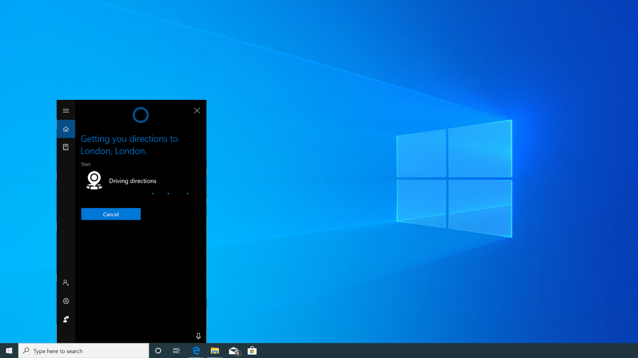

Fig 3.19: Get directions

Cortana can respond with directions. Ask for “directions to [location]” and Cortana will open the included Windows 10 Maps app with directions to your chosen location.

## Set Alarms

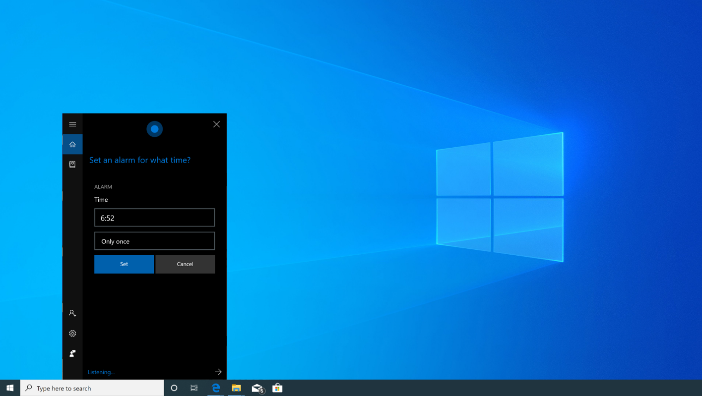

Fig 3.20: Set alarms

Cortana also supports alarms. Ask Cortana to “set alarm for [time]” and it will create an alarm for you. The alarm is saved in the Alarms & Clock app where you can subsequently manage them.

## Launch Programs

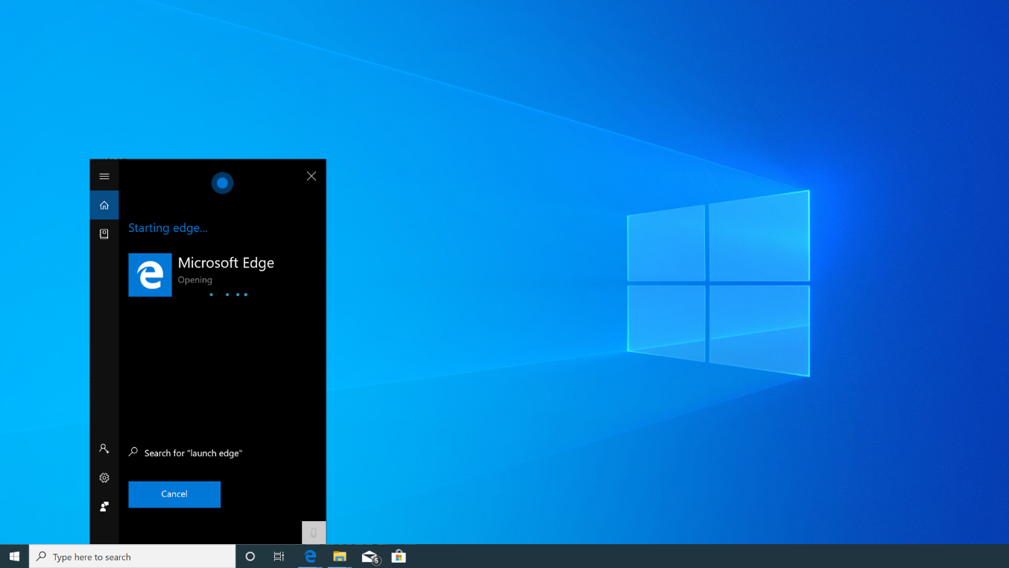

Fig 3.21: Launch programs

Cortana can launch programs for you. Just say “Launch [program name].” If you have the “Hey Cortana” voice shortcut enabled, this means you can just say “Hey Cortana, launch Edge” to your PC and it will automatically open the app for you

## Send Emails

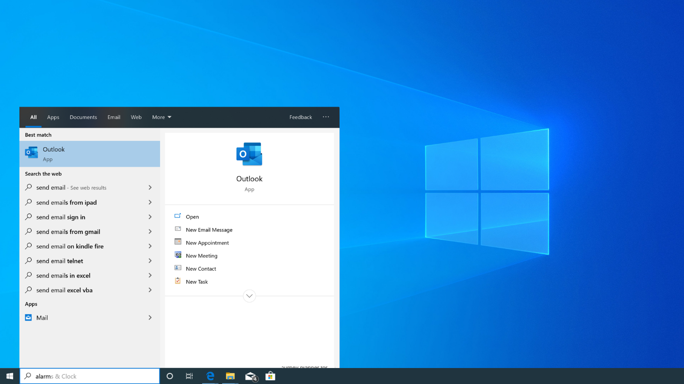

Fig 3.22: Send E-mails

Cortana can send emails using the built-in Mail app and your configured accounts. Just say “send email” to get started or say something more specific like “Send email to [Person in your contacts]”. Cortana will search your contacts and begin an email to the e-mail address associated with that person.

## Chat

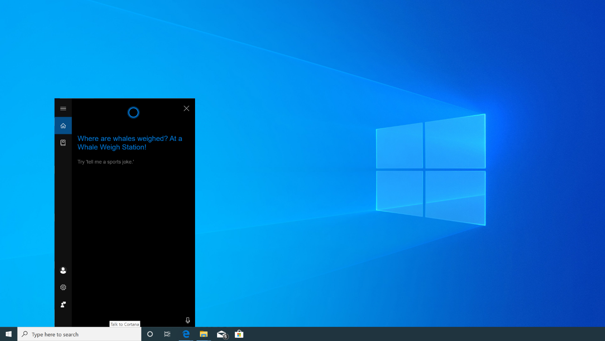

Fig 3.23: Chat

Cortana can “chat” with you about things and respond to even mindless questions with snappy answers. Ask Cortana a question such as “Where’s Clippy?” or even give ask it to “Tell me a story”, or “Tell me a joke”.

## Get a List of Commands/Help

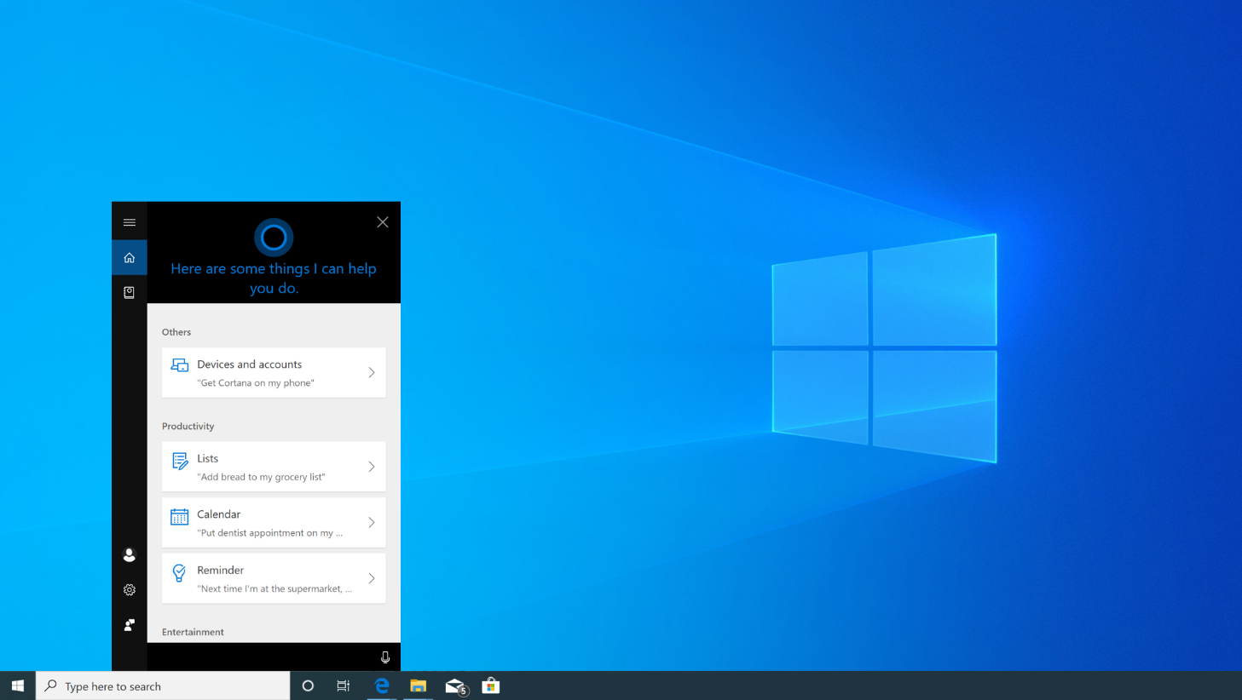

Fig 3.24: Help

If you need a list of commands that Cortana can help you with the easiest way to do this is simply ask for them. Just say “Help” and you’ll see a list of things you can do with Cortana and

a complete list will be shown of the functions.

Many of the best uses of Speech Recognition and other such services is in the support of those in society with disabilities. These services can greatly enhance their independence and in doing so their quality of life.

# Speech recognition

(Content and image: courtesy - <https://www.bing.com/translator>)

The application Bing Translator helps people in need of a translation from one spoken language to another. Whilst other applications can translate text, Bing Translator also allows for a conversation in 2 or more languages to take place. Starting the application is easy and can be completed in three steps:

* Go to [www.bing.com/translator](http://www.bing.com/translator) and click on the Conversation Tab
* Click on "Start conversation", login and enter your name and language.
* Share the conversation code with other participants, who can join in the conversation using the Translator app or website in their native language.
* Speak or type in your native language to communicate with other participants in the conversation. They will see your messages in their language and vice versa.

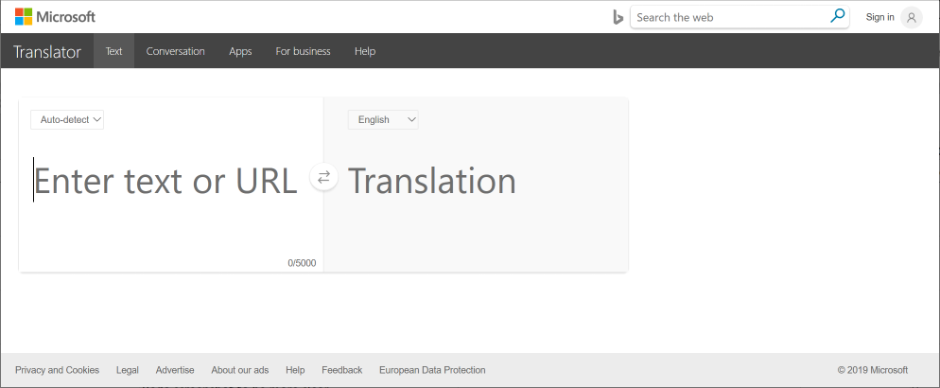

Fig 3.25: Speech Recognition

## Points to remember

* A participant who has left the conversation can return using the conversation code.
* New participants can only see the conversation that takes place after they join the conversation. Prior history of the conversation is not visible to new participants.
* You can invite participants to your conversation by sharing the five-letter code or the QR code assigned to the conversation.
* If you are the person who has started the conversation, leaving the conversation or closing the browser tab will end the conversation for all participants.

# Spell Checker

(Content and image: Courtesy - <https://docs.microsoft.com/en-us/azure/cognitive-services/bing-spell-check/overview>)

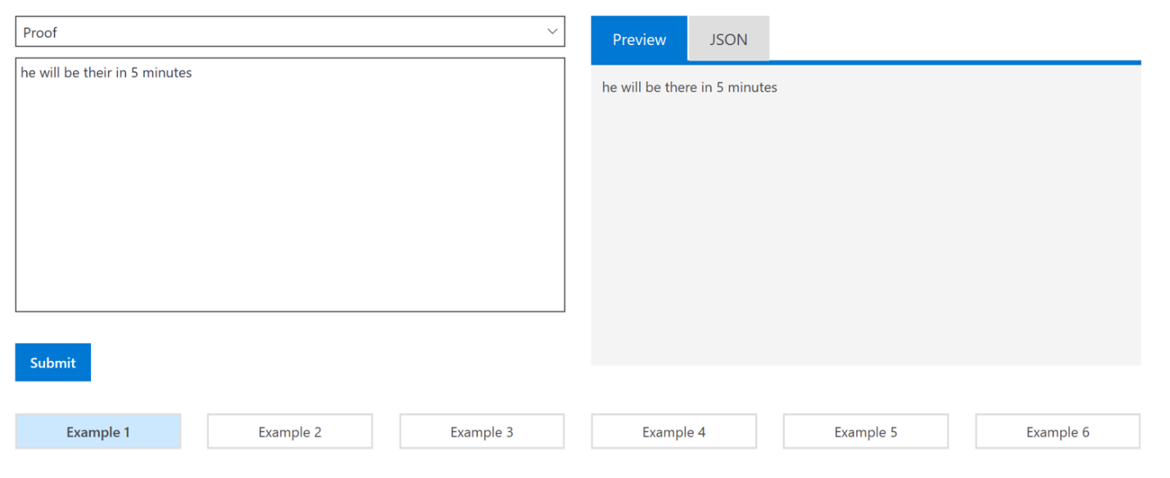

Fig 3.26: Bing Spell Checker

The Bing Spell Check API enables contextual grammar and spell checking to be performed on text. While most spell-checkers rely on dictionary-based rules, the Bing spell-checker leverages machine learning and statistical machine translation to provide more accurate and contextual corrections.

Features:

* Multiple spell check modes enable corrections focused on grammar and/or spelling.
* Recognize common expressions and informal terms used in the text.
* Find the correct usage between words that sound similar but differ in meaning (for example, ‘see’, ‘sea’ and ‘Si’).
* Recognize new brands, titles, and other popular expressions as they emerge.

Exposure to Cloud based AI, & Online   
Collaboration Tools

# Online collaboration tool

A collaboration tool as the name suggests helps people collaborate or work together. The purpose of the tool is to support a group of two or more individuals to accomplish a common goal or objective. Collaboration tools can be non-technological such as paper, flipcharts, post-it notes, or whiteboards.

Imagine managing a team with members from all over the world. How do you collaborate with these remote colleagues frequently and conveniently? How do you manage to get everyone on the same page, and ensure that they get the latest updates on the project? It can be challenging not only the remote workers but also for in-house teams in a large organization to keep pace with upcoming tasks. It has become easier with the use of online collaboration tools that help in the management of workflow amongst team members in small and big businesses.

There are plenty of collaboration tools on the market today. Online collaboration software is not made for just remote location workers but is also a valuable tool for any organization that wants to be more efficient and effective. It empowers teams to optimize resources, execute projects, promote transparency, share files efficiently, and achieve unparalleled collaboration. AI-enhanced collaboration tools have the potential to increase efficiency, speed up the discovery of new ideas and lead to improved outcomes for teams that are working together in different locations.

Online collaboration tools contain some useful features such as private and shared calendars, the ability to upload documents, send notifications, hold voice and video calls, and many other features. One of the best collaboration tools on the market today is Microsoft Teams which is available for devices that run Windows, and for other operating systems. That it is available for every platform means that no matter what device you use you will be able to collaborate with other team members. For more information on Teams you can visit <https://docs.microsoft.com/en-us/microsoftteams/teams-overview>

# Insights into Data using Power BI

The entire Power BI setup consists of:

* A Windows desktop application called Power BI Desktop
* An online SaaS (Software as a Service) service called the Power BI service
* Power BI mobile apps for Windows, iOS, and Android devices

Power BI provides cloud-based "Power BI Services", along with a desktop-based interface, called "Power BI Desktop". It offers data warehouse capabilities including data preparation, data discovery and interactive dashboards. Microsoft released an additional service called Power BI Embedded on its Azure cloud platform. One main differentiator of the product is the ability to load custom visualizations. You can download the Power BI Desktop and Power BI Publisher for Excel to establish a connection between the two for seamless integration,

To find out more about Power BI watch these videos which demonstrates how it can be used.

[Video: Microsoft Power BI Embedded](https://youtu.be/NbsLRDMWNRI)

[Video: Heathrow Airport transforms the travel experience with Power BI](https://youtu.be/peeSZfPS-KU)

AI Applications

# Introduction to AI Applications on Azure

There are many cognitive services that a student can use to understand the Azure platform which is easy to understand and use. These modules the students incorporate features of the cognitive services into their application and assist in making AI an integral part of their problem-solving approach.

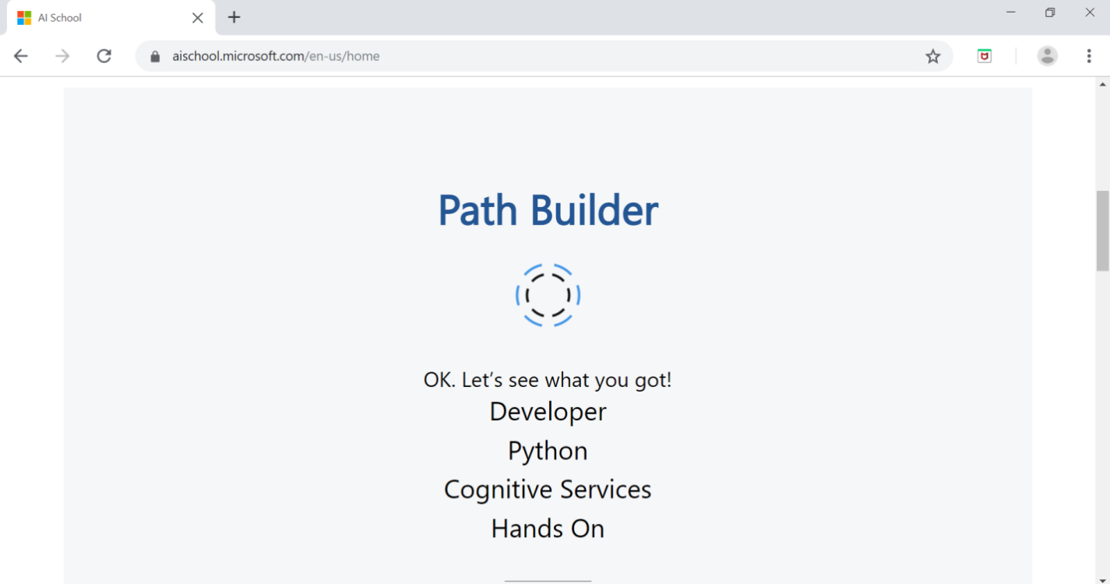

Fig 3.27: Path Builder on AI School

In this section, you will learn about the various cognitive services that Azure, as a service, has to offer. The video provides an overview to the world of cognitive services, getting started, and building AI applications on Azure. The link to the tutorial video to the introduction of the topic is as follows:

<https://aischool.microsoft.com/en-us/machine-learning/learning-paths/ai-and-cognitive-services-applications-on-azure/overview>

The video is a tutorial that is aimed at understanding how one can easily add the various powerful intelligence capabilities offered by Microsoft to applications designed with the help of Microsoft Cognitive services.

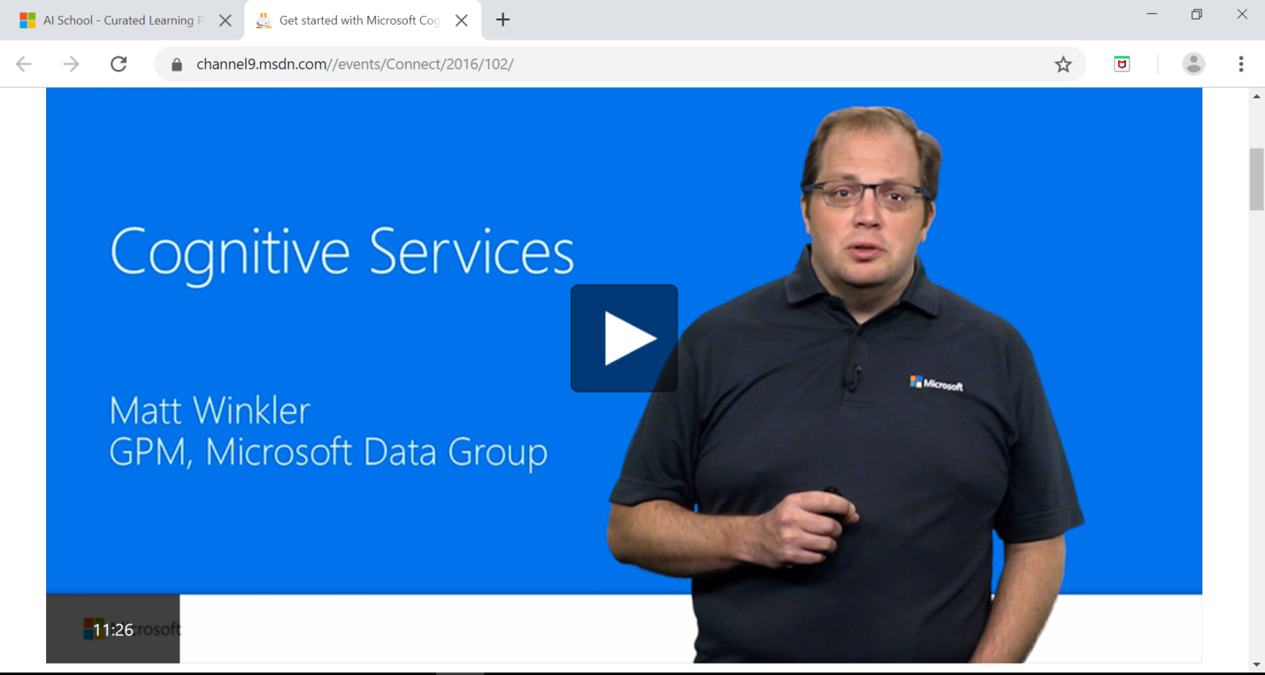

Fig 3.28: Screenshot of a Video on the Cognitive Services

In the link below you will encounter the various steps that are required to integrate the cognitive tools with the AI-based services available to students.

<https://aischool.microsoft.com/en-us/machine-learning/learning-paths/ai-and-cognitive-services-applications-on-azure/introduction-and-setup-infuseai>

In these steps you will see performed various AI-based cognitive services such as face recognition or processing of human speech.

<https://aischool.microsoft.com/en-us/machine-learning/learning-paths/ai-and-cognitive-services-applications-on-azure/the-processing-phase-inputs>

You can design applications which can be integrated using the given cognitive services.

# Cognitive Services - Face API

Very often, when you upload photos of your face, solo or in a group, onto a social media page the social media app tags you. It also tags all those people who are friends with you on your account, or whose telephone numbers have been stored in your telephone contacts. In short, if your phone is synced with the cloud, then all contacts you have can be tagged. Have you ever wondered how that is possible? How can social media recognize your or your friends’ faces in photos that it has never seen before, i.e. new images? Face recognition is a highly developed AI-based application that recognizes various key points on the human face.

The cloud-based Face API provides developers with access to such advanced face algorithms. Click on the link to learn how to analyze content in different ways with Quick Starts, Tutorials, and samples.

<https://aischool.microsoft.com/en-us/services/learning-paths/cognitive-services-face-api>.

# AI Developer Boot Camp

The link below guides you deeper into AI through the high-level concepts and technologies of the Microsoft AI platform. Click on the link to explore more in terms of the various technologies that are applicable in the spectrum of AI:

<https://aischool.microsoft.com/en-us/machine-learning/learning-paths/ai-developer-bootcamp>

# Drone Rescue

The learning path takes the developer through the process of using ‘AirSim’ to generate synthetic training data for a Custom Vision model. The next step is to train the Custom Vision model and export it to ‘TensorFlow’ format. The model loads on any edge device to allow recognition of stuffed animals in a field. This same approach can then be used to expand to various other scenarios to create a Custom Vision model to recognize different types of objects. Click on the link below to explore more -

<https://aischool.microsoft.com/en-us/autonomous-systems/learning-paths/drone-rescue>.

Cognitive Services

# AI Natural Language Processing

One of the many challenges often faced by artificial intelligence is understanding human speech. With immense diversity in language, the process of deciphering human speech is exceedingly difficult. At times, the machine faces difficulties in learning constructs because there seem to be more exceptions to the rules of a language than rules themselves. This is particularly true in languages such as English.

The Language Understanding Intelligent Service (LUIS) solves these challenges to a greater extent. It enables developers to build smart applications that can understand human language and react accordingly to user requests. LUIS uses the power of machine learning to solve the difficult problem of extracting meaning from natural language input. Any client application that converses with users, such as a dialog system or chatbot, can pass user input to a LUIS application and receive results.

# Optical Character Recognition

This topic is divided into four modules. Each module is aimed at understanding a separate section on how OCR is processed. Each module is then further divided into sub-modules which consist of hands-on activities and videos. The main modules are:

* Introduction to the modules
* Capabilities of the OCR cognitive services
* Exploration of the OCR methods
* Building an application from PDF Material

This module provides an overview of the Cognitive Services- OCR API and shows how to build an application using it.

# Image Classification

This hands-on lab guides you through creating an intelligent console application end-to-end, using Cognitive Services (specifically the Computer Vision API). We use the Image processing portable class library (PCL), discussing its contents and how to use it in applications.

In this module, you will:

* Learn about the various Cognitive Services APIs
* Understand how to configure your apps to make use of Cognitive Services
* Build an application that calls various Cognitive Services APIs (specifically Computer Vision) in .NET applications

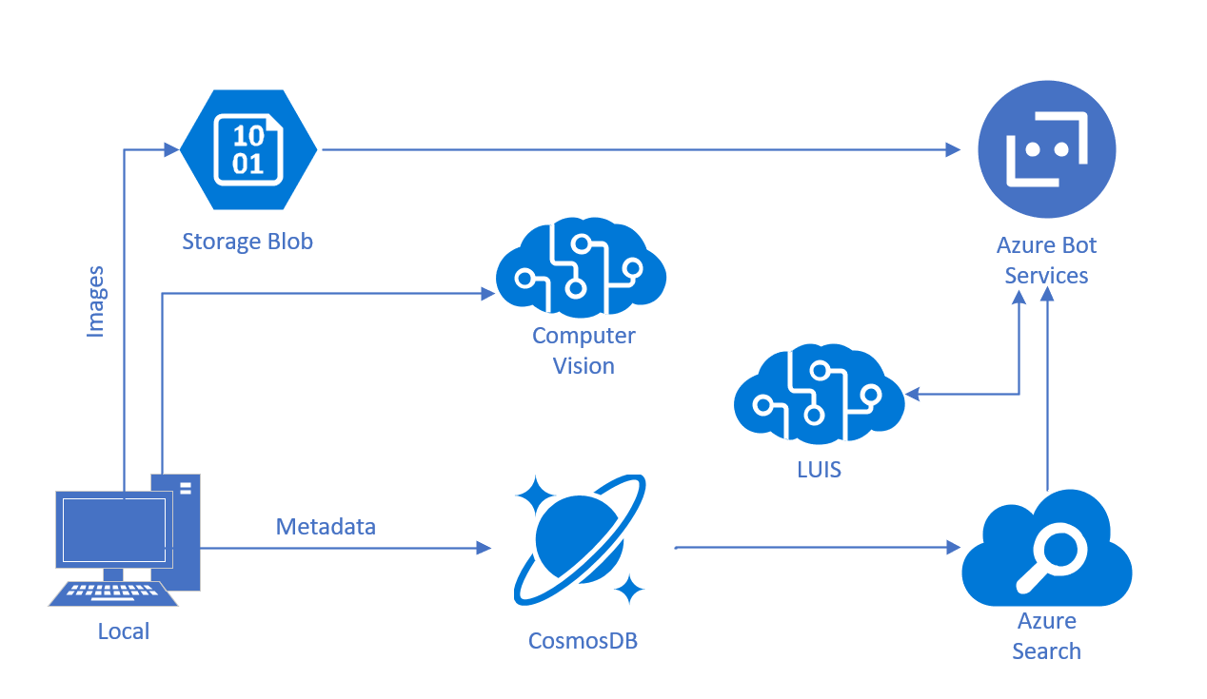

Fig 3.29: Computer Vision API Framework

Textbook Assessments

Sentiment analysis is widely applied to:

1. Reviews from customer
2. Survey responses
3. Online and social media
4. All of the above

Cortana is:

1. Microsoft’s Digital assistant
2. Intel’s Digital assistant
3. Facebook’s Digital assistant
4. Apple’s Digital assistant

True or False

* Artificial Intelligence uses instances created by human intelligence. (**True**/False)
* Language analysis cannot predict emotions. (**True**/False)
* Cortana is a personal assistant. (True/**False**)
* Video indexer can analyze videos and segment them. **(True**/False)
* Cortana can find programs in the computer and perform online searches. (**True**/False)

1. What is Sketch2code? Detail the basic steps involved in working with Sketch2code.

* <https://neelbhatt.com/2018/08/26/convert-your-sketch-to-html-code-with-sketch2code-microsoft-ai/>

1. What is a spell checker? Describe how it works? Where can you use the spell checker?
2. What is speech recognition? Describe how it helps people. State its application in real life scenarios.
3. Give examples of online collaboration tools that are commonly used along with their uses.
4. Detail the major differences between Power BI services and Power BI embedded services.
5. What is the purpose of an online collaboration tool?
6. How does AI help in Collaboration?

Practical Assignments

# Assignment 1

**Title:** Finding a route to the railway station from your home

* Step 1. Use an appropriate map service e.g. a browser Map, Cortana etc.
* Step 2. Find the map from your home location to your local railway station.
* Step 3. Save the map and directions.

# Assignment 2

You are part of a team that have entered a competition to test your business skills in selling products that you make in your school/college. You have decided that you want so setup a series of webpages that will promote your business and also your products. You need to present some finished web designs to your board so you can gain their permission to setup the website and start to operate it. Using Sketch2Code design 3 webpages which will form part of your website. Link -

<https://sketch2code.azurewebsites.net>

Consider the following questions after you have completed the exercise.

* Did this make the task you were set easier to achieve?
* If so, then explain how it made it easier? If not, then consider the reasons why that was not the case?
* In your opinion is this a useful tool for businesses to adopt in the future and why?

# Assignment 3

Construct an excel sheet to share it with the educators to facilitate the input of marks. Each educator should input the data (marks of each student for each subject) using any online collaboration tool deemed fit for processing further.

Assignments/Questions to Ponder Upon

Demonstrate Image Classification using Deep Neural Networks –

* <https://medium.com/@tifa2up/image-classification-using-deep-neural-networks-a-beginner-friendly-approach-using-tensorflow-94b0a090ccd4>

Give 5 Amazing Examples of Natural Language Processing (NLP) In Practice –

* <https://www.forbes.com/sites/bernardmarr/2019/06/03/5-amazing-examples-of-natural-language-processing-nlp-in-practice/#3ead98fd1b30>

Enlist the uses of digital assistants in different sectors and its applications.

* <https://www.smartsheet.com/voice-assistants-artificial-intelligence>

How is a spell checker using cognitive services different from the common spell checker?

* <https://docs.microsoft.com/en-us/azure/cognitive-services/bing-spell-check/overview>

Analyze the best practices in dashboard designing.

* <https://www.justinmind.com/blog/6-best-practices-for-dashboard-design/>
* <https://www.datapine.com/blog/dashboard-design-principles-and-best-practices/>

Evaluate ways to restrict access to the data using AI.

* <https://towardsdatascience.com/ai-and-the-future-of-privacy-3d5f6552a7c4>
* <https://www.globalsign.com/en/blog/5-ways-cybersecurity-can-gain-from-ai/>
* <https://dzone.com/articles/how-ai-takes-cybersecurity-to-the-next-level>

Evaluate different online storages and their features and benefits?

* <https://beginnersbook.com/2013/04/advantages-and-disadvantages-of-online-data-storage/>

What is a sync cloud? Trace out the steps to use cloud storage on Android?

* <https://searchstorage.techtarget.com/answer/What-is-the-difference-between-cloud-file-syncing-and-cloud-storage>

List down the differences between cloud storage and online backup? State with examples.

* <https://www.informationweek.com/consumer/online-backup-vs-cloud-storage/d/d-id/1107440>

Enumerate the challenges encountered by face recognition if the look of a person is drastically changed (in accident or in a plastic surgery)?

* <https://warwick.ac.uk/fac/sci/dcs/research/df/identity/publications/deceiving_faces.pdf>

Can the detection of facial emotions be made through CCTV footage during theft scenes?

* <https://www.hindawi.com/journals/jhe/2018/7961427/>

How do you think emotion detection API works accurately - with images or with videos?

* <https://blog.affectiva.com/emotion-ai-101-all-about-emotion-detection-and-affectivas-emotion-metrics>
* <https://nordicapis.com/20-emotion-recognition-apis-that-will-leave-you-impressed-and-concerned/>

What are the various popular methods of text to speech conversions?

* <https://en.wikipedia.org/wiki/Speech_synthesis>
* <https://www.investintech.com/resources/blog/archives/5301-convert-text-speech.html>

What can be the possible disadvantages of text to speech conversions at the early stages of learning in a child?

* <https://www.researchgate.net/publication/325554736_Speech_synthesis_systems_Disadvantages_and_limitations>
* <https://www.explainthatstuff.com/how-speech-synthesis-works.html>

What type of hardware/software support would be needed for it to run in a noisy environment?

* <https://www.nap.edu/read/4761/chapter/12>

Further Reading

* Security of biometrics and biometric data

<https://us.norton.com/internetsecurity-iot-biometrics-how-do-they-work-are-they-safe.html?inid=nortoncom_isc_iot-how-facial-recognition-software-works-ReadMore-internetsecurity-iot-biometrics-how-do-they-work-are-they-safe.html>

* Anti-Face recognition glasses

<https://qz.com/823820/carnegie-mellon-made-a-special-pair-of-glasses-that-lets-you-steal-a-digital-identity/>

* Tensor Flow – The machine learning library explained

<https://www.infoworld.com/article/3278008/what-is-tensorflow-the-machine-learning-library-explained.html>

* Power BI – Getting started - <https://docs.microsoft.com/en-us/learn/modules/get-started-with-power-bi/>
* Power BI – Get data with Power BI - <https://docs.microsoft.com/en-us/power-bi/guided-learning/gettingdata>
* Power BI - Get data from Excel - <https://docs.microsoft.com/en-us/power-bi/guided-learning/powerbiandexcel>
* Power BI – Create a Power BI dashboard - <https://docs.microsoft.com/en-us/power-bi/service-dashboard-create>
* What Are Collaboration Tools? - <https://study.com/academy/lesson/what-are-collaboration-tools-definition-types-quiz.html>
* What is Azure? - <https://azure.microsoft.com/en-gb/overview/what-is-azure/>
* Cloud computing: A complete guide - [www.ibm.com/cloud/learn/cloud-computing](http://www.ibm.com/cloud/learn/cloud-computing)
* Top Uses of Speech Recognition Technology - <https://www.sestek.com/2014/11/introduction-to-speech-recognition/>

Reference Links

* Azure.microsoft.com. (2019). Bing Spell Check| Microsoft Azure. [online] Available at: https://azure.microsoft.com/en-in/services/cognitive-services/spell-check/ [Accessed 29 Jun. 2019].
* Azure.microsoft.com. (2019). *Face API - Facial Recognition Software | Microsoft Azure*. [online] Available at: https://azure.microsoft.com/en-in/services/cognitive-services/face/ [Accessed 29 Jun. 2019].
* Docs.microsoft.com. (2019). Generate data insights automatically with Power BI - Power BI. [online] Available at: https://docs.microsoft.com/en-us/power-bi/service-insights [Accessed 11 Jul. 2019].
* Eisenhauer, T. (2014). How Online Collaboration Tools Benefit Your Business. [online] Axero Solutions. Available at: https://axerosolutions.com/blogs/timeisenhauer/pulse/180/how-online-collaboration-tools-benefit-your-business [Accessed 11 Jul. 2019].
* Ibm.com. (2019). *Cloud computing: A complete guide*. [online] Available at: https://www.ibm.com/cloud/learn/cloud-computing [Accessed 29 Jun. 2019].
* Kashyap, V. (2019). 28 Best Online Collaboration Tools of 2019 for Business. [online] ProofHub. Available at: https://www.proofhub.com/articles/best-online-collaboration-tools-business [Accessed 11 Jul. 2019].
* Prezi.com. (2019). Collaboration Tools. [online] Available at: https://prezi.com/p/gpqlovdvt3ia/collaboration-tools/ [Accessed 11 Jul. 2019].
* Symanovich, S. (2019). *How does facial recognition work?* [online] Us.norton.com. Available at: https://us.norton.com/internetsecurity-iot-how-facial-recognition-software-works.html [Accessed 9 Sep. 2019].

Glossary

**AirSim:** AirSim is a simulator for drones, cars and more, built on Unreal Engine. It is open-source, cross platform, and supports hardware-in-loop with popular flight controllers

**Algorithm**: A process or set of rules to be followed in calculations or other problem-solving operations, especially by a computer.

**Attributes**: A quality or feature regarded as a characteristic or inherent part of a person.

**Chatbots**: A computer program designed to simulate conversation with human users, especially over the Internet.

**Cloud Storage**: It is a service model in which data is maintained, managed, backed up remotely and made available to users over a network (typically the Internet). Users generally pay for their cloud data storage on a per-consumption, monthly rate.

**Data Loss**: It is an error condition in information systems in which information is destroyed by failures or neglect in storage, transmission, or processing. Information systems implement backup and disaster recovery equipment and processes to prevent data loss or restore lost data.



